Supplemental material

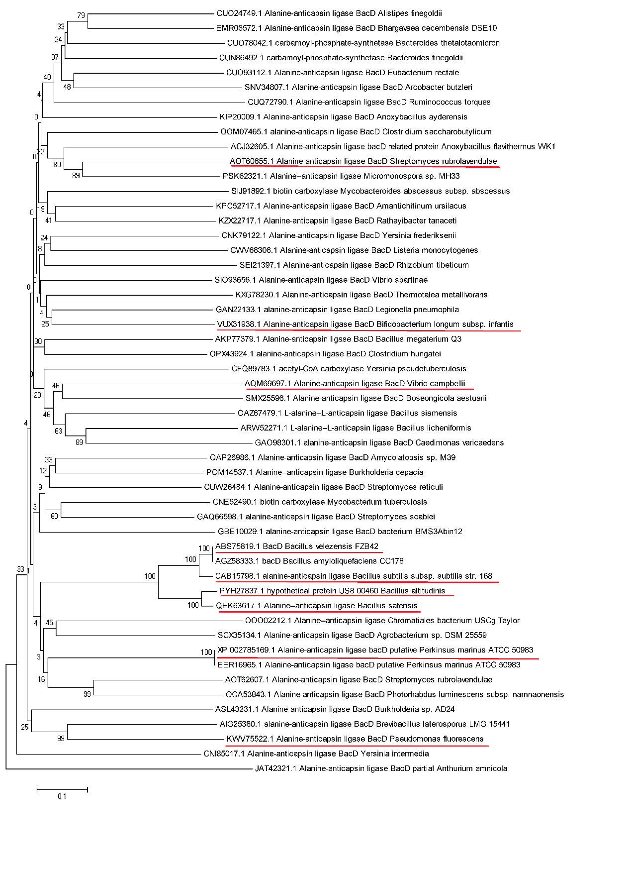
Fig. S1 Phylogenetic tree of BacD homologs.
The BacD homologs studied in this study were underlined.

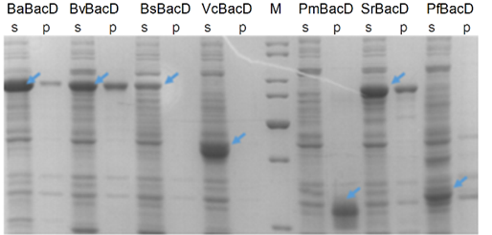
Fig. S2 SDS-PAGE analysis of BacD homologs in E.coli
M: marker, s: supernatant, p: precipitate. BaBacD, BacD from Bacillus altitudinis; BsBacD, BacD from Bacillus subtilis; BvBacD, BacD from Beta vulgaris; VcBacD, BacD from Vibrio campbellii; PmBacD, BacD from Perkinsus marinus; SrBacD, BacD from Streptomyces rubrolavendulae; PfBacD, BacD from Pseudomonas fluorescens.

Fig. S3 SDS-PAGE analysis of strains co-expressing CgGlnA and BacD.
M: marker, 1: the supernatant of p11/AQ10, 2: the precipitate of p11/AQ10, 3: the supernatant of p12/AQ10, 4: the precipitate of p12/AQ10, 5: the supernatant of p13/AQ10, 6: the precipitate of p13/AQ10, 7: the supernatant of p14/AQ10, 8: the precipitate of p14/AQ10.

Fig. S4 SDS-PAGE analysis of strains by RBS optimization.
M: marker, 1: the supernatant of p11/AQ10, 2: the precipitate of p11/AQ10, 3: the supernatant of p15/AQ10, 4: the precipitate of p15/AQ10, 5: the supernatant of p16/AQ10, 6: the precipitate of p16/AQ10.
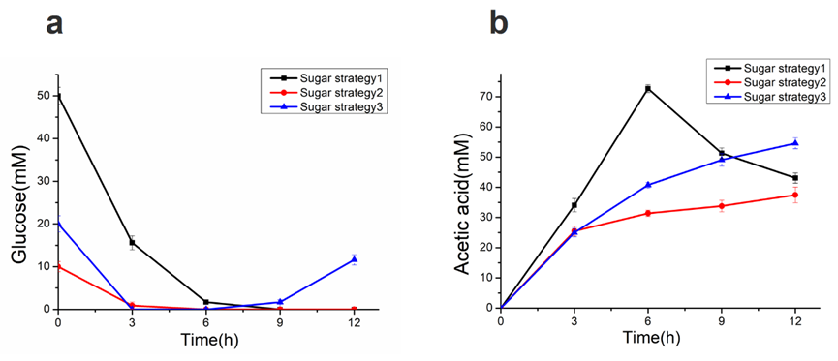
Fig. S5 Concentration of glucose and acetic acid in the conversion.
a Effects of different feeding strategies on residual glucose. b Effects of different feeding strategies on acetic acid concentration.

